THE COMPARATIVE FORM OF THE ADJECTIVES  + er short adjectives  + r short adj. Ending in  –e (safe/ safer)  + ier short adj. Ending in  -y (cloudy/cloudier)  Short adjectives  Double the final  consonant, +er  short adj. Ending in  vowel + consonant  (big/bigger)  Long adjectives More+adj  Irregular form ( better, worse) | Cheaper, nearer  Safer  Easier + than  More dangerous  worse
Older
Smaller
Higher
Cheaper
Better
Worse
Bigger
Heavier
More expensive
larger
lower
Faster
shorter
Scarier
nearer
safer
Noisier
More exciting
More dangerous
More enjoyable
My car is faster than yours  Mi coche es más rápido que el tuyo | To be + adjective comparative + than
SUPERLATIVE ADJECTIVES  + est short adjectives  + st short adj. Ending in  –e (safe/ safest)  + iest short adj. Ending  in -y  Short adjectives (cloudy/cloudiest)  Double the final  consonant, +est  short adj. Ending in  vowel + consonant  (big/biggest)  Long adjectives the most +adj  Irregular form ( best, worst) | We use than when we compare two people, places or things.
The hottest
The driest
The sunniest
The wettest
The highest
The sacariest
The coldest
New /newest  Small/smallest  High/ highest  Good/best  Expensive/ the most expensive  Sunny/the sunniest  Dry/driest  Long/the furthest  Busy/ busiest | Nuevo/ el más nuevo  Pequeño  Alto  Bueno  Caro  Soleado  Seco  Largo  ocupado
ASKING FOR TRAVEL INFORMATION  What´s the best way to get to (place) from here?  What´s the best way to get there?  How often do the (bus/train) leave?  They go every 20 minutes  How much is a ticket? A single is $20 and return is $30  Do you know when the next metro is? There´s one every ten minutes  How long does the journey take? It takes about 25 minutes from here  Sorry! No discounts  How long does the journey take?  When´s the next bus?  One -way ticket /single ticket  Return ticket (UK)/ round-trip ticket (USA)  An adult's ticket  A child's ticket | ¿Cuál es la mejor forma de llegar desde aquí?  ¿Cuál es la mejor forma de llegar allí?  ¿Con qué frecuencia sale el bus? (Van) cada 20 minutos  ¿Cuánto cuesta el billete?  ¿Sabes cuándo es el próximo metro? Hay uno cada 10 minutos  ¿Cuanto dura el viaje? lleva unos 25 minutos desde aquí  ¡Lo siento! Sin descuentos  ¿Cuanto dura el viaje?  ¿Cuándo es el próximo autobús?  Billete de ida  Billete de ida y vuelta  Boleto de adulto  Boleto de niño
WEATHER

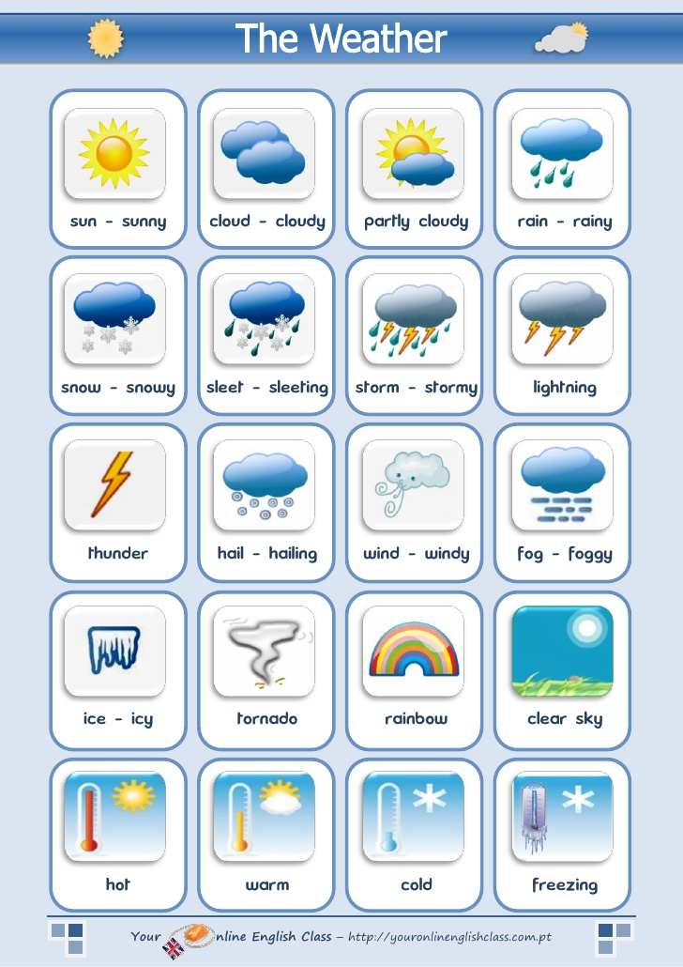
SLEET/ SLEETING= AGUANIEVE
LIGHTNING= RAYO
THUNDER= TRUENO
HAIL/ HAILING= GRANIZO
FREEZING= HELADO, CONGELADO
PARTLY CLOUDY= PARCIALMENTE NUBLADO
BLIZZARD= TORMENTA DE NIEVE, VENTISCA
DRIZZLE= LLOVIZNA, SIRIMIRI
CYCLONE, HURRICANE, TORNADO, TWISTER
