Vocabulary

1 Complete the puzzle according to the pictures.
4
Across 
5
6
8
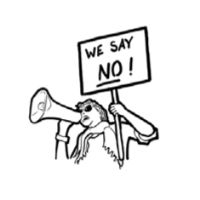 |  | 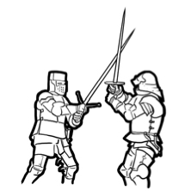 |  | 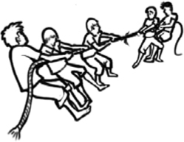 |  | 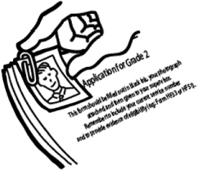

 |  |  |  |  |  |  |  | ¹
 |  |  | ² |  |  |  |  |  |  |  | ³
 |  | ⁴
⁵ |  |  |  |  |  |  |  |  | ⁶ |  |  | ⁷
 |  |  |  |  |  |  | ⁸
Down 
1
2
3
5
7
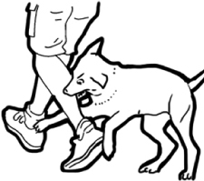 |  | 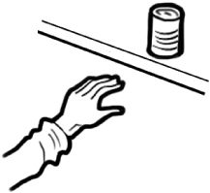 |  | 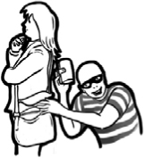 |  | 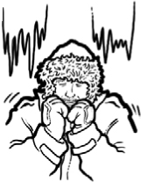 |  | 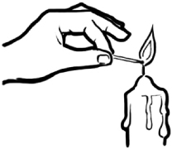

2 Unscramble the verbs to complete the sentences.
1. More than 50 people …………………… at the local hospital. (lonreuevt)
2. I’m working hard to …………………… my school marks. (evirpom)
3. Flowers need water and sunlight to …………………… . (vevsuir)
4. She held my arm to …………………… me from falling. (tenverp)
5. Did your dog …………………… your life? (aevs)
6. The inventor wants to …………………… a special microscope. (podevle)
7. Can I …………………… some money and give it back to you tomorrow? (robrow)
8. It’s important to …………………… the street at the traffic lights. (sorsc)

Grammar

3 Complete the sentences with the verbs below. Use the Past Simple affirmative.
see  begin  teach  close  hear  travel
1. Yesterday, our teacher …………………… us a beautiful song.
2. Bethany …………………… to India last month.
3. We …………………… a good film last week.
4. The shop …………………… at 1.00 yesterday.
5. We …………………… the news yesterday.
6. The exam …………………… an hour ago.

4 Write sentences with the words below. Use the affirmative or negative
form of the Past Simple to make them true for you.
1. my family / eat / chicken and potatoes / yesterday

2. I / volunteer / last summer

3. my friends and I / do / sport / last weekend

4. my class / have / a test / last week

5. I / fight / with my friend / a week ago

6. there / be / a great film / on TV / last night

5 Complete the questions with the Past Simple form of the verbs in brackets.
Then match the questions to the answers below.
1. What painting …………………… Vincenzo Peruggia …………………… (steal) in 1911?
2. When …………………… Edmund Hillary and Tenzing Norgay …………………… (reach)
the top of Mt Everest?
3. What …………………… Microsoft …………………… (develop)?
4. When …………………… the Wright brothers …………………… (invent) the aeroplane?
5. Where …………………… divers …………………… (find) the Titanic?
...... a. In 1903.
...... b. Windows.
...... c. The Mona Lisa.
...... d. At the bottom of the Atlantic Ocean.
...... e. In May, 1953.

