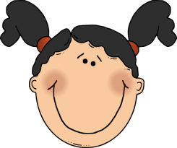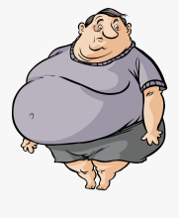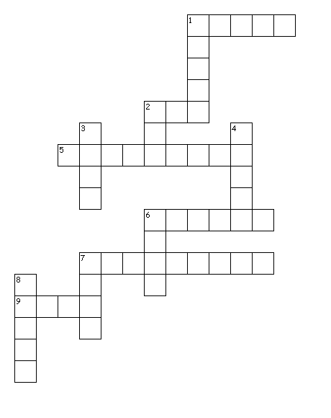

**8**

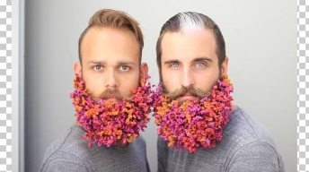

**2**

**4**

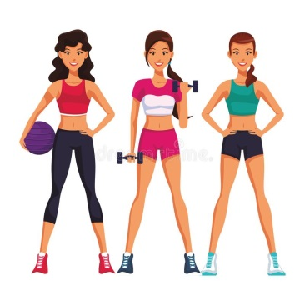

**6**

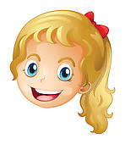

**2**

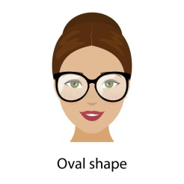

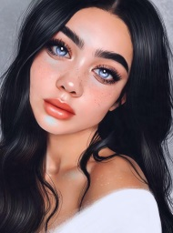

**9**

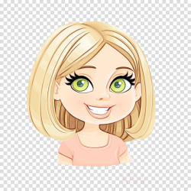

**7**

**6**

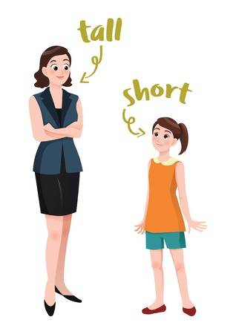

**1**

**5**

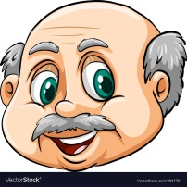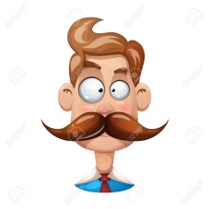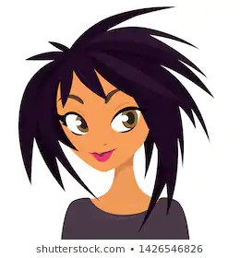

**1**

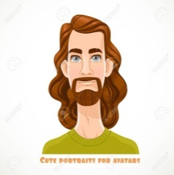

**7**

**3**

**Down:**

**1.** Someone who isn't tall.

**2.** Someone who isn't fit.

**3.** His hair isn't short.

**4.** They are very funny. They put flowers in their _________________.

**6.** Her eyes are _________________.

**7.** A person who has no hair.

**8.** His face is _________________.

**Across:**

**1.** She has _________________ purple hair.

**2.** Someone who exercises and isn't fat.

**5.** He doesn't have a beard.   
He has a _____________________.

**6.** A person who has yellow hair.

**7.** A woman who is very good looking.

**9.** Her face is _________________.

**HANANE MIMOUNI**



**p**

**y**

**i**

**k**

**S**

**8**



**h**

**2**

**4**

**o**

**r**



**t**

**i**

**f**

**6**



**a**

**e**

**r**

**a**

**b**

**l**

**2**



**h**

**o**

**a**

**t**

**S**

**c**

**m**

**u**



**g**

**n**

**9**



**b**

**e**

**n**

**d**

**o**

**l**

**7**

**l**

**e**

**l**

**u**

**f**

**i**

**t**

**u**

**a**

**b**

**e**

**a**

**r**

**6**



**l**

**o**

**v**

**a**

**1**

**5**



**d**

**u**

**1**

**n**

**d**



**7**

**3**

**Across:**

**1.** She has **spiky** purple hair.

**2.** Someone who exercises and isn't fat. **fit**

**5.** He doesn't have a beard. He has a **moustache**.

**6.** A person who has yellow hair. **blonde**

**7.** A woman who is very good looking. **beautiful**

**9.** Her face is **oval**.

**Down:**

**1.** Someone who isn't tall. **short**

**2.** Someone who isn't fit. **fat**

**3.** Her hair isn't short. **long**

**4.** They are very funny. They put flowers in their **beard**.

**6.** Her eyes are **blue**.

**7.** A person who has no hair. **bald**

**8.** His face is **round**.

**HANANE MIMOUNI**