What is Artificial Intelligence (or Machine Learning?)

Link: https://www.youtube.com/watch?v=mJeNghZXtMo

1. Every day, a large portion of the population is at the mercy of a rising technology, yet few actually understand what it is. Artificial intelligence. You know, HAL 9000 and Marvin the Paranoid Android? Thanks to books and movies, each generation has formed its own fantasy of a world ruled -- or at least served -- by robots. We've been conditioned to expect flying cars that steer clear of traffic and robotic maids whipping up our weekday dinner. But if the age of AI is here, why don't our lives look more like the Jetson's? Well, for starters, that's a cartoon. And really, if you've ever browsed

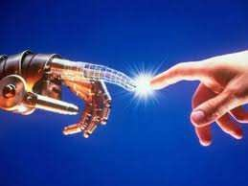

Netflix movie suggestions or told Alexa to order a pizza, you're probably interacting with artificial intelligence more than you realize.

1. And that's kind of the point. AI is designed so you don't realize there's a computer calling the shots. But that also makes understanding what AI is, and what it's not, a little complicated. In basic terms, AI is a broad area of computer science that makes machines seem like they have human intelligence. So it's not only programming a computer to drive a car by obeying traffic signals, but it's when that program also learns to exhibit signs of human-like road rage.
2. As intimidating as it may seem, this technology isn't new. Actually, for the past half-a-century, it's been an idea ahead of its time. The term Artificial Intelligence was first coined back in1956 by Dartmouth professor John McCarthy. He called together a group of computer scientists and mathematicians to see if machines could learn like a young child does, using trial and error to develop formal reasoning. The project proposal says they'll figure out how to make machines "use language, form abstractions and concepts, solve kinds of problems now reserved for humans, and improve themselves."
3. That was more than 60 years ago. Since then, AI has remained for the most part in university classrooms and super-secret labs ...But that's changing. Like all exponential curves, it's hard to tell when a line that's slowly ticking upwards is going to skyrocket. But during the past few years, a couple of factors have led to AI becoming the next "big" thing:
4. First, huge amounts of data are being created every minute. In fact, 90% of the world's data has been generated in the past two years. And now thanks to advances in processing speeds, computers can actually make sense of all this information more quickly. Because of this, tech giants and venture capitalists have bought into AI and are infusing the market with cash and new applications. Very soon, AI will become a little less artificial, and a lot more intelligent.
5. Now the question is: Should you brace yourself for yet another Terminator movie, live on your city streets? Not exactly. In fact, stop thinking of robots. When it comes to AI, a robot is nothing more than the shell concealing what's actually used to power the technology. That means AI can manifest itself in many different ways. Let's break down the options. First, you have your bots. They're text-based and incredibly powerful, but they have limitations. Ask a weather bot for the forecast, and it will tell you it's partly cloudy with a high of 57. But ask that same bot what time it is in Tokyo, and it'll get a little confused. That's because the bot's creator only programmed it to give you the weather by pulling from a specific data source. Natural language processing makes these bots a bit more sophisticated. When you ask Siri or Cortana where the closest gas station is, it's really just translating your voice into text, feeding it to a search engine, and reading the answer back in human syntax.
6. So in other words, you don't have to speak in code. At the far end of the spectrum is machine learning, and honestly, it's one of the most exciting areas of AI. Like a human, a machine retains information and becomes smarter over time. But unlike a human, it's not susceptible to things like short-term memory loss, information overload, sleep deprivation, and distractions.
7. But how do these machines actually learn? Well, while it may be easy for a human to know the difference between a cat and a dog, for a computer, not so much. You see, when you're only considering physical appearance, the difference between cats and dogs can be a little gray. You can say cats have pointed ears and dogs have floppy ears, but those rules aren't universal. Between tail length, fur texture, and color, there are a lot of options, and that means a lot of tedious rules someone would have to program manually to help a computer spot the difference.
8. But remember -- machine learning is about making machines learn like humans. And like any toddler, that means they have to learn by experience. With machine learning, programs analyse thousands of examples to build an algorithm. It then tweaks the algorithm based on if it achieves its goal. Over time, the program actually gets smarter. That's how machines like IBM's Watson can diagnose cancer, compose classical symphonies, or crush Ken Jennings at Jeopardy. Some programs even mimic the way the human brain is structured, complete with neural networks that help humans -- and now machines -- solve problems.
9. Generations have long imagined the ramifications of AI, visualizing a society where machines seek revenge and wreak havoc on human society. However, the more logical and pressing question is: How will AI affect your job? Will it make your work obsolete? Just like the Industrial Revolution, it's not human versus machine. It's human and machine versus problem. The point is that artificial intelligence helps you accomplish more in less time, taking on the repetitive tasks of your job

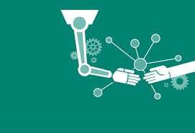

while you master the strategy and relationships. That way, humans can do what they do best … be human.

|  |  |
| --- | --- |
| **at the mercy** | **a situation that is controlled by someone or something with the power to harm you. Workers are entirely at the mercy of dishonest employers.** |
| **rising** | **going up, ascending, mounting, advancing** |
| **steer clear** | **to avoid someone or something** |
| **maid** | **a girl or woman servant** |
| **whip up** | **informal to prepare something to eat very quickly** |
| **for starters** | **used to say that something is the first in a list of things** |
| **browse** | **to examine casually** |
| **the point** | **the matter being discussed** |
| **calling the shots** | **to be the person who makes all the important decisions and who has the most power in a situation** |
| **broad** | **having great extent or expanse** |
| **road rage** | **violent anger caused by the stress and frustration involved in driving a motor vehicle in difficult conditions** |
| **coin** | **to make up; devise; invent (a new word or phrase)** |
| **trial and error** | **The process of experimenting with various methods of doing something until one finds the most successful.** |
| **formal reasoning** | **is a kind of calculation, deductive reasoning; logic.** |
| **figure out** | **solve, resolve,** |
| **improve** | **to raise to a better quality or condition; make better** |
| **exponential curve** | **the rate of change becomes exponential when it starts increasing or decreasing so fast that the plot line becomes vertical** |
| **ticking upwards** | **an increase, occurring in small jumps** |
| **skyrocket** | **increase very steeply or rapidly** |
| **infusing** | **fill, imbue, pervade, permeate** |
| **brace yourself** | **prepare yourself for something difficult or unpleasant** |
| **conceal** | **to put out of sight; hide** |
| **break down** | **to separate, or to separate something, into smaller parts: Can you break down our expenses by month and by region** |
| **bot** | **a computer program that works automatically, especially one that searches for and finds information on the internet** |
| **forecast** | **to estimate or calculate in advance; predict or seek to predict** |
| **source** | **something is supplied that provides information** |
| **search engine** | **a program that searches for and identifies items in a database that correspond to keywords or characters specified by the use** |
| **syntax** | **the arrangement of words and phrases to create well-formed sentences in a language** |
| **spectrum** | **a continuous range or entire extent** |
| **short- term memory** | **information retained in the brain and retrievable from it over a brief span of time** |
| **overload** | **too great a load** |
| **deprivation** | **to keep from having, using, or enjoying** |
| **floppy** | **to fall or drop; soft and flexible** |
| **tail** | **the rear end of an animal's body** |
| **length** | **the measure of how long a thing is** |
| **fur** | **the soft, thick hair covering the body of many mammals** |
| **tweak** | **to make a minor adjustment to: to tweak a computer program** |
| **algorithm** | **a predetermined set of instructions for solving a specific problem in a limited number of steps** |
| **achieve** | **to do; succeed in doing; accomplish** |
| **goal** | **an object or end that one strives to attain; aim** |
| **ramification** | **a derived effect, consequence, or result** |
| **seek** | **to try to find; search for; look for** |
| **revenge** | **to inflict damage, injury, or punishment in return for (an injury, insult, etc.); retaliate for** |
| **wreak** | **to inflict (vengeance), cause (harm or havoc), etc.** |
| **havoc** | **great destruction and devastation** |
| **master** | **to become an expert in** |

**Vocabulary Questions; Use the vocabulary words and phrases below to fill in the blank spaces; some word forms will need to be changed.**

**At the mercy, broad, trial and error, figure out, skyrocket, break down, deprivation, achieve, goal, seek, revenge, master.**

**Artificial Intelligence is slowly making progress, but it could soon ______________ into a new trend in technology.**

**If you want to _____________ your _____________of learning English, you will have to study a lot.**

**Many computer scientist are now trying to ___________ ________ how computers can learn to think like humans.**

**Many movies have been produced about robots _____________ _____________ on humanity.**

**Many people suffer from insomnia, which is simply sleep _____________.**

**People today are ____ ______ __________ of the rising technology of Artificial Intelligence.**

**There are many different branches of Artificial Intelligence. It is a ____________ field.**

**To ______________ a language usually takes many years of study and exposure to the language.**

**We learn many lesson from our mistakes. We all learn by __________ ____ __________.**

**You can ________ ____________ Artificial Intelligence into 6 major branches: robotics, vision systems, natural language processing, learning systems, neural networks and expert systems.**

What is Artificial Intelligence: Questions

1. Do many people today interact with Artificial Intelligence?
2. What is AI?

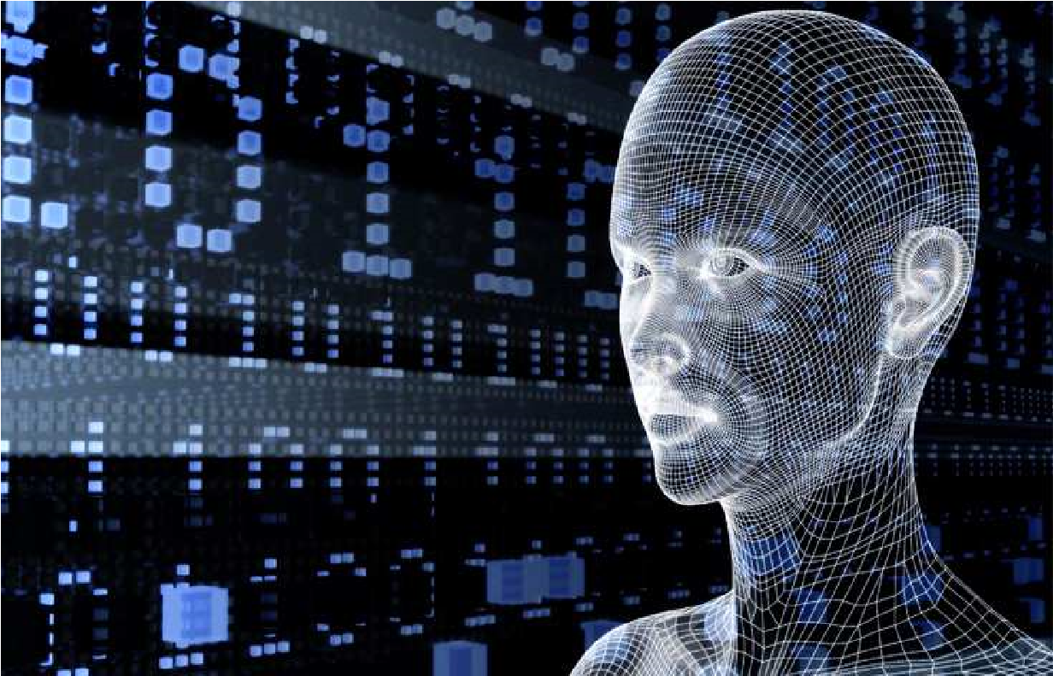

1. How long has Artificial Intelligence been around?
2. What has happened to Artificial Intelligence during the last few years?
3. What has caused AI to have the ability to improve so much in recent years?
4. What is a bot?
5. What advantages does machine learning have over human learning?
6. What advantages does human learning have over machines?
7. What functions can Watson, IBM’S computer preform?
8. Do you think Robots will eventually take over the world? What is a more likely problem humans will face in the future if Artificial Intelligence becomes the next big thing?

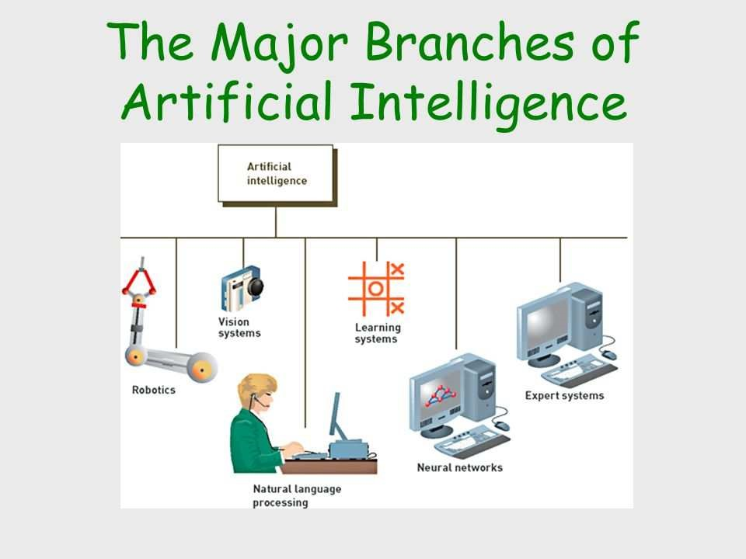

**Key**

**Vocabulary questions**

* 1. **skyrocket**
  2. **achieve, goal**
  3. **figure out**
  4. **seeking revenge**
  5. **deprivation**
  6. **at the mercy**
  7. **broad**
  8. **master**
  9. **trail and error**
  10. **break down**

**Key to video script comprhension questions**

* 1. **yes, a large portion of the population**
  2. **Artificial Intelligence**
  3. **1956**
  4. **It's making rapid progress**
  5. **advances in processing speeds and large amounts of data stored**
  6. **a computer program that researches the internet and gives you the information on a specific topic**
  7. **no short term memory loss, information overload, sleep deprivation, or distractions**
  8. **ability to makes leaps in judgment without having to calculate so many factors**
  9. **diagnose cancer, compose classical symphonies, play games like Jeopardy**
  10. **individual answers, a more logical questions is: how will computers effect your job.**