

# Activity 1: Read the article

**Artificial Intelligence May Doom The Human Race Within A Century, Oxford Professor Says**

*Posted: 08/22/2014 12:04 pm EDT Updated: 08/25/2014 7:59 pm EDT*

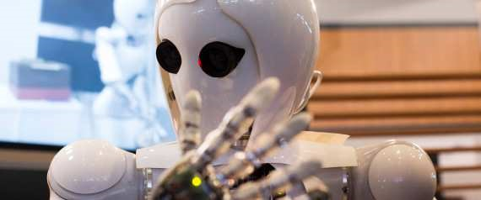

An Oxford philosophy professor who has studied existential threats ranging from nuclear war to superbugs says the biggest danger of all may be superintelligence.

Superintelligence is any intellect that outperforms human intellect in every field, and Nick Bostrom thinks its most likely form will be a machine -- artificial intelligence.

There are two ways artificial intelligence could go, Bostrom argues. It could greatly improve our lives and solve the world's problems, such as disease, hunger and even pain. Or, it could take over and possibly kill all or many humans. As it stands, the catastrophic scenario is more likely, according to Bostrom, who has a background in physics, computational neuroscience and mathematical logic.

"Superintelligence could become extremely powerful and be able to shape the future according to its preferences," Bostrom told me. "If humanity was sane and had our act together globally, the sensible course of action would be to postpone development of superintelligence until we figure out how to do so safely."

Bostrom, the founding director of Oxford's Future of Humanity

Institute, lays out his concerns in his new book, *Superintelligence: Paths, Dangers, Strategies*. His book makes a harrowing comparison between the fate of horses and humans:

Horses were initially complemented by carriages and ploughs, which greatly increased the horse's productivity. Later, horses were substituted for by automobiles and tractors. When horses became obsolete as a source of labor, many were sold off to meatpackers to be processed into dog food, bone meal, leather, and glue. In the United States, there were about 26 million horses in 1915. By the early 1950s, 2 million remained. The same dark outcome, Bostrom said, could happen to humans once AI makes our labor and intelligence obsolete.

It sounds like a science fiction flick, but recent moves in the tech world may suggest otherwise. Earlier this year, Google acquired artificial intelligence company DeepMind and created an AI safety and ethics review board to ensure the technology is developed safely. Facebook created an artificial intelligence lab this year and is working on creating an artificial brain. Technology called "deep learning," a form of artificial intelligence meant to closely mimic the human brain, has quickly spread from Google to Microsoft, Baidu and Twitter. (...)

In an interview about his book Bostrom points aout that there are few people working full time on AI control problem. They need more brilliant brains to this technical work. His hope is that his book will do something to encourage that. ‘How to control superintelligent AI is really the most important task of our time -- yet, it is almost completely ignored.’ says Bostrom.

*Retrieved from: http://www.huffingtonpost.com*

# Activity 2: Read the text again and choose the correct option

**1.** Superintelligence:

1. is a substitute for the human intellect.
2. will possibly take form of a machine.
3. is a machine replacing the human intellect.
4. is any intellect which is better than the human one in some fields.

**2**. According to Bostrom artificial intelligence

1. is going to kill all the humanity.
2. will probably be harmful for us.
3. could be a solution for major problems.
4. improves the humanity’s intelligence

**3.** Bostrom’s advice is

1. to stop developing superintelligence for ever
2. for people to join forces and improve superintelligence.
3. the best way would be to give up developing superintelligence.
4. to find some ways of controlling the superintelligence.

**4**. The problem with the horses was that

1. they were not productive any more.
2. they were more useful for humanity for their meat than for their labor.
3. they were a source of labor for meatpackers.
4. their labor was taken over by cars.

**5.** Bostrom says

1. controlling the AI is an urgent problem which people ignore.
2. the main task is to control brilliant brains.
3. more intelligent people are needed to overtake the AI’s work.
4. his book will bring the change in controlling the AI.