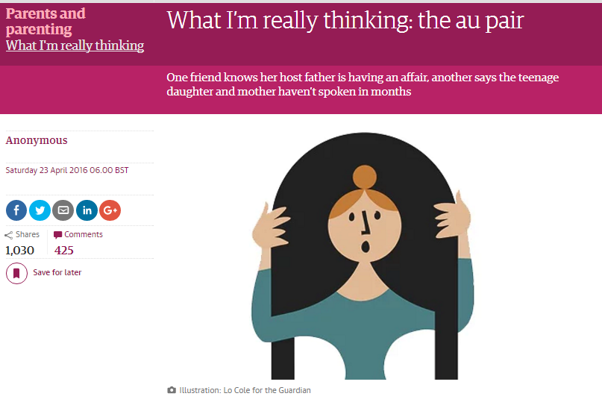
I can tell a lot about somebody’s upbringing when they ask what I do. While most just nod, working-class people tend to look a little confused, and the upper class ask if I’m “like a nanny for poor people”.
A
Au pairs see your dirty laundry up close – literally and figuratively. One friend knows her host father is having an affair, another says the teenage daughter and mother haven’t spoken in months.
C
B
I do everything a nanny would do, only I’m a teenager, completely unqualified, and paid much less than the minimum wage. And I don’t speak your language very well.
Another family apparently have the most appalling personal hygiene. One local au pair is assumed to be sleeping with the father, but that seems too clichéd to be true.
D
Sometimes I wonder what I’m still doing here. I’ve had injuries after tantrums, and a child screaming, “Go home, you’re ugly and evil.” Living with my boss is a strange dynamic. You can rave about how your au pair is part of the family, but I guarantee she resents you a little – and you resent her, too.
E
My host family pays for my travel expenses and some of my food. I’ve met amazing friends, and learned a lot about life – and more about cooking. I’m also sorry for breaking your ladle.
F
I get on well with my host parents, but feel their frustration over little things, for example a spoon left on the counter. It’s a feeling I share when I have to cancel cinema plans for last-minute babysitting – for the third week running.
G
Other days I think I have the best job in the world. I don’t pay for accommodation and I live in the centre of an incredible city, in an apartment I could never afford. My weekends are entirely free.
H
1 | 2 | 3 | 4 | 5 | 6 | 7 | 8
A | C | B | D | E | G | H | F

I can tell a lot about somebody’s upbringing when they ask what I do. While most just nod, working-class people tend to look a little confused, and the upper class ask if I’m “like a nanny for poor people”.
I do everything a nanny would do, only I’m a teenager, completely unqualified, and paid much less than the minimum wage. And I don’t speak your language very well.
Au pairs see your dirty laundry up close – literally and figuratively. One friend knows her host father is having an affair, another says the teenage daughter and mother haven’t spoken in months.
Another family apparently have the most appalling personal hygiene. One local au pair is assumed to be sleeping with the father, but that seems too clichéd to be true.
Sometimes I wonder what I’m still doing here. I’ve had injuries after tantrums, and a child screaming, “Go home, you’re ugly and evil.” Living with my boss is a strange dynamic. You can rave about how your au pair is part of the family, but I guarantee she resents you a little – and you resent her, too.
I get on well with my host parents, but feel their frustration over little things, for example a spoon left on the counter. It’s a feeling I share when I have to cancel cinema plans for last-minute babysitting – for the third week running.
Other days I think I have the best job in the world. I don’t pay for accommodation and I live in the centre of an incredible city, in an apartment I could never afford. My weekends are entirely free.
My host family pays for my travel expenses and some of my food. I’ve met amazing friends, and learned a lot about life – and more about cooking. I’m also sorry for breaking your ladle.

