Cartesian product and correspondences

The Cartesian product of two sets A and B (also called the product set, set direct product, or cross product) is defined to be the set of all ordered pairs (a,b) where a∈A and b∈B. It is denoted A×B. $A×B=\left\{\left(a,b\right)|a∈A,b∈B\right\}$

Some relations map some points in a set A to one or several points in a set B. These relations can be saw as a subset of A×B and are called correspondences.
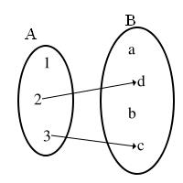
Example:
A={1,2,3} B={a,b,c,d}
A×B.={(1,a),(1,b),(1,c),(1,d),(2,a),(2,b),(2,c),(2,d),(3,a),(3,b),(3,c),(3,d)}
a correspondence {(2,d),(3,c)}

Types of correspondences:
- left-total: for all a∈A there exists a b∈B such that a is mapped to b
- right-total or surjective: for all b∈B there exists an a∈A such that a is mapped to b
- function: for all a∈A there exists a unique element b∈B such that a is mapped to b

Note: a left-total correspondence where at least one point in set A is map to several points in B is called a multivalued function (or multiple-valued function).

Functions

A function (or map or mapping) from A to B is a relation that associates every element in A to a unique element in B. It is an object f such that for every a∈A, there is a unique element f(a)∈B.
The set A is called the domain (the set of “inputs”)
The set B is called the codomain (the set of allowable “outputs”)
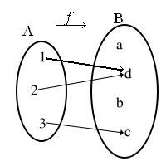
The range of the function f is the subset of elements of the codomain which correspond to some element in the domain.

Example: domain A={1,2,3} codomain B={a,b,c,d}
a function f={(1,d),(2,d),(3,c)}
f(1)=d f(2)=d f (3)=c
range {d,c}

Note: Generally speaking, the symbol f refers to the function itself, while f(x) refers to the value taken by the function when evaluated at a point.

Functions from a number set to a number set

We can mainly distinguish between functions over the reals and functions over the naturals. The latter are known as sequences.

Functions over the reals

When a function is defined with words its description is usually vague and probably inaccurate.
Examples: the image of “x” under f is the difference between its cube and its product by nine
a function g maps every real number to its square

A function can be specified by tabulating the arguments x and their corresponding values f(x)
If the domain is finite, a function f may be perfectly defined this way.
Examples: x | –4 –3 –2 –1 0 1 2 3 4
y | –28 0 10 8 0 –8 –10 0 28

x | –4 –3 –2 –1 0 1 2 3 4
g(x) | 16 9 4 1 0 1 4 9 16

A function can be specified by means of a graph.
The graph of a function f is the collection of all ordered pairs (x,f(x)).
In particular, graph means the graphical representation of this collection in a Cartesian coordinates system. Graphing on a Cartesian plane is sometimes referred to as curve sketching.

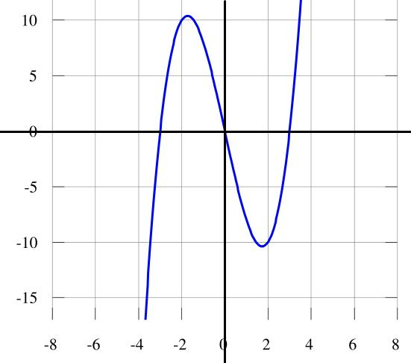
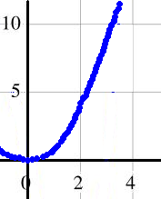
Examples

More commonly, a function is defined by a formula or an algorithm (that is, a recipe that tells how to compute the value of f(x) given any x in the domain).
Notations commonly used to represent functions from a subset of R to R:
- The notation $f:x↦f\left(x\right)$ specifies that f is a function acting upon a single number x and returning a value f(x).
- We can use variable y to represent the value associated to x (mainly when a name for the function is not needed)
- The notation $f:A↦B$, where $f\left(x\right)=\text{.}\text{.}\text{.}$ is used to explicitly specify the domain of the function.
Examples:
$f:x↦x^{3}−9x$ $y=x^{3}−9x$ $f\left(x\right)=x^{3}−9x$ $f:R↦R$ where $f\left(x\right)=x^{3}−9x$
$g:x↦x^{2}$ $y=x^{2}$ $g\left(x\right)=x^{2}$ $g:Z↦R$ where $g\left(x\right)=x^{2}$

Some functions over the reals map many numbers to the same number: many-to-one functions
In other functions over the reals different numbers of the range correspond to different numbers of the domain: one-to-one functions

Examples:
f(x)=sin x (many-to-one) f(x)=x (one-to-one) f(x)=x² (two-to-one but for x=0)

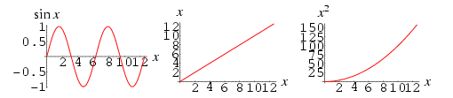

Some vocabulary of functions and graphs

If you write a function f in the form y = f(x), y is considered dependent on x and x is said to be the independent variable.
A specific input value to a function is called an argument of the function.
For each argument x, the corresponding unique y in the codomain is called the function value at x, or the image of x under f.
The image of x may be written as f(x) or as y.

The graph of a function f from real numbers over real numbers is the set of all ordered pairs
(x, f(x)), for all x in the domain.
These ordered pairs are the Cartesian coordinates of points (x is the abscissa and f(x) is the ordinate)

If A is any subset of the domain, then f(A) is the subset of the range consisting of all images of elements of A. We say the f(A) is the image of A under f.
If B is any subset of the codomain, then the subset f^{–1}(B) = {x in X | f(x) is in B} is the preimage (or inverse image) of B under f.

Note: the range of f is the image of its domain.

Note: some graphs of relations reveal that the relation is not a function; that happens when more than one element of the codomain are correspondent to an element of the domain.

