**1º de PRIMARIA**

ULTIMA SEMANA DO CURSO!

Nesta ultima semana imos aprender por enriba o vocabulario dos temas que nos quedaron por ver.

**UNIT 5: LET’S DANCE!**

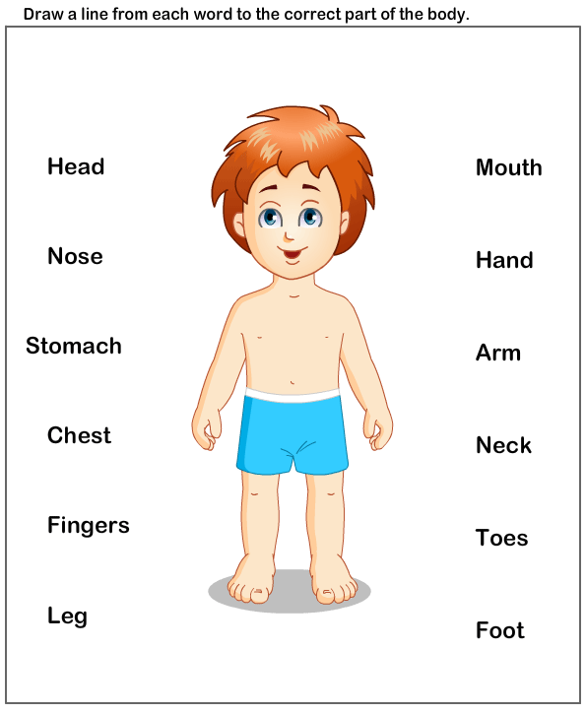

ARM

FOOT

NOSE

KNEE

LEG

HAND

HEAD

TOES

Podemos aprender e practicar a pronunciación deste novo vocabulario entrando na páxina de:

<https://www.go.richmonddigital.net/>

**Username**: richmond2020 **password**: richmond

Ou mirando estes videos de Youtube:

<https://www.youtube.com/watch?v=SUt8q0EKbms>

<https://www.youtube.com/watch?v=QkHQ0CYwjaI>

<https://www.youtube.com/watch?v=-6-Q1yTEx54>

**ACTIVITIES:**

<https://es.liveworksheets.com/worksheets/en/English_as_a_Second_Language_(ESL)/Body_Parts/The_body_lq782156cz>

**UNIT 6: THAT’S DELICIOUS**

|  |  |  |  |
| --- | --- | --- | --- |
| **CHEESE** | **YOGURT** | **FISH** | **CHICKEN** |
| Cheese, Cream Milk Cheese Cartoon, cheese, food, rectangle, cheese ... | Freehand Textured Cartoon Yogurt Royalty Free Cliparts, Vectors ... | Fish Cartoon png download - 2917*2917 - Free Transparent Food png ... | Pollo asado - Iconos gratis de comida |
| **FRUIT** | **MEAT** | **SALAD** | **SOUP** |
| Frutero - Xogo de fíos | Goat Cartoon png download - 1600*793 - Free Transparent Steak png ... | Salad Cartoon Images, Stock Photos & Vectors | Shutterstock | Vegetable, Soup, Food, Noodle, Noodle Soup, Cartoon, Bowl, Egg ... |
| **CAKE** |  |  |  |
| Cute birthday cake cartoon Royalty Free Vector Image |  |  |  |

Podedes aprender este vocabulario entrando na páxina web ou con algún video como este:

<https://www.youtube.com/watch?v=ROl8kRESCvM>

**ACTIVITIES**

<https://es.liveworksheets.com/worksheets/en/English_as_a_Second_Language_(ESL)/Food/Food_names_mv784729qz>

As fichas enviaredesmas da mesma forma que a semana pasada: unha vez acaben de facela darlle a **TERMINADO** e elixen a opción “Enviar mis respuestas al profesor”. Despois poñen nome, curso e materia e enviana ao meu correo electrónico: [cristina.curras@edu.xunta.es](mailto:cristina.curras@edu.xunta.es)

THAT’S ALL!

HAVE GOOD SUMMER HOLIDAYS!!!

SEE YOU IN SEPTEMBER!

