
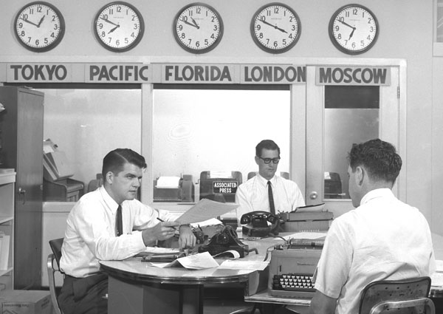
WHAT DO THEY DO?
♣ WRITE THESE SENTENCES UNDER THE CORRESPONDING PICTURE:
-They work in a hospital. - She meets people from different countries.
- They wear an uniform. - She speaks three languages.
- She helps people. - They work on a computer
- She sells things. - She works in a shop.
- They help sick people. - She translates things.
- She works at the United Nations. - They ask people questions.
- They work in a newspaper office. - They work with doctors.
- She looks after money. - They write a lot.


They work in a hospital.

