Clothing line
Follow the instructions below.
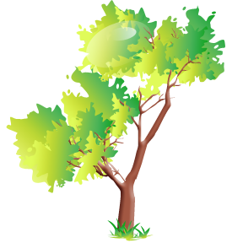
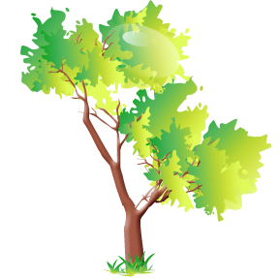

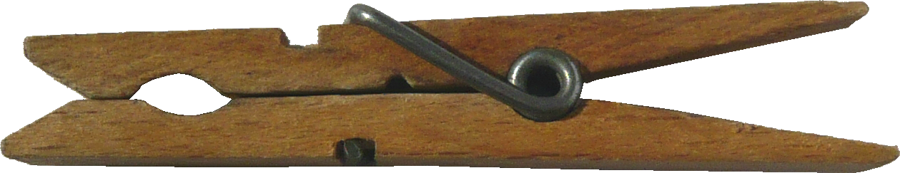
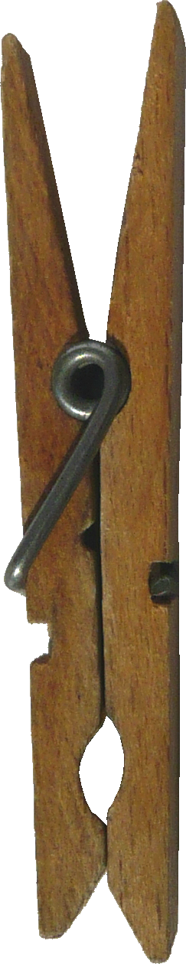
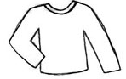
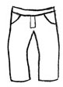
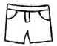
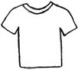

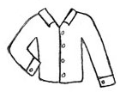
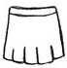
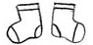

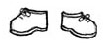

Colour the t-shirt blue. | Colour the socks green.
Colour the skirt pink. | Colour the trousers yellow.
Colour the jumper red. | Colour the shirt purple.
Colour the shoes orange. | Colour the hat black.
Colour the shorts white.

