**NUMBERS 1**

**NAME:**

**☺ LISTEN AND COLOUR.**



**FIVE**

**FOUR**

**THREE**

**TWO**

**ONE**

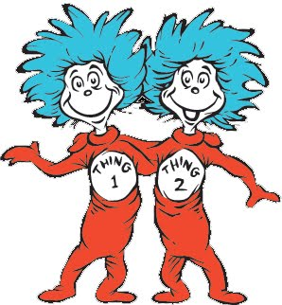

**☺ LOOK AND MATCH.**

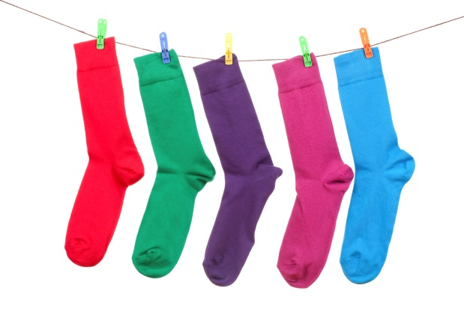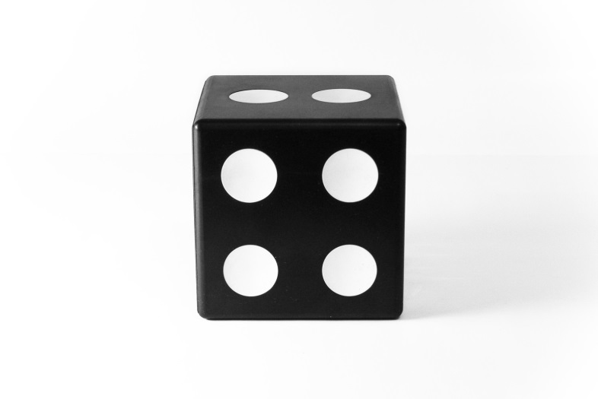

**ONE**

**TWO**

**THREE**

**FOUR**

**FIVE**

☺ FIND THE NUMBERS

**1- ONE**

**2- TWO**

**3- THREE**

**4- FOUR**

**5- FIVE**

☺ COUNT AND WRITE THE NUMBER

**ONE**

**TWO**

**THREE**

**FOUR**

**FIVE**



|  |  |  |  |  |
| --- | --- | --- | --- | --- |
| F | O | U | R | O |
| W | V | E | H | N |
| T | H | R | E | E |
| W | T | F | O | I |
| O | F | I | V | E |

