Meet Bob!
Minion FunSheet for Cute Little Beginners
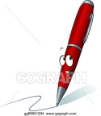
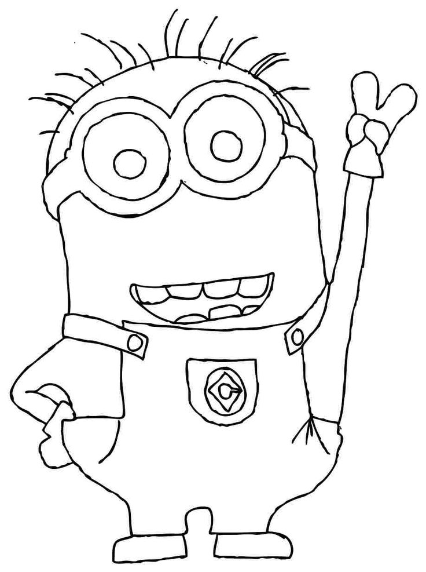
1. - Hello there!
___________________
(HELLO! / GOOD BYE! / THANK YOU! )

- What’s your name?
My name is __________________.

- Nice to meet you! I’m Bob, the Minion! Are you a BOY or a GIRL?
I am a _________.

- How old are you?
I am _______ years old.
2. Wow! Please help me!
a) Colour my…

ARMS – YELLOW MOUTH - RED
HEAD – YELLOW HANDS (GLOVES) - BLACK
EYES – GREEN BODY (OVERALL) - ORANGE
TOES (SHOES) - BLUE
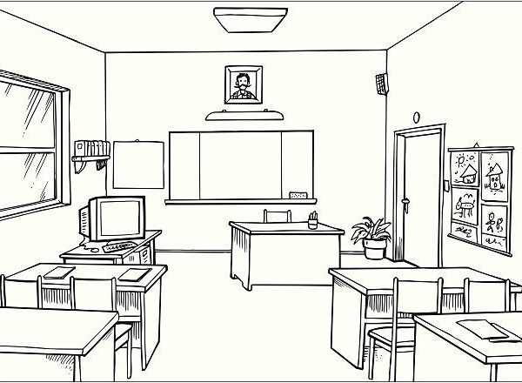
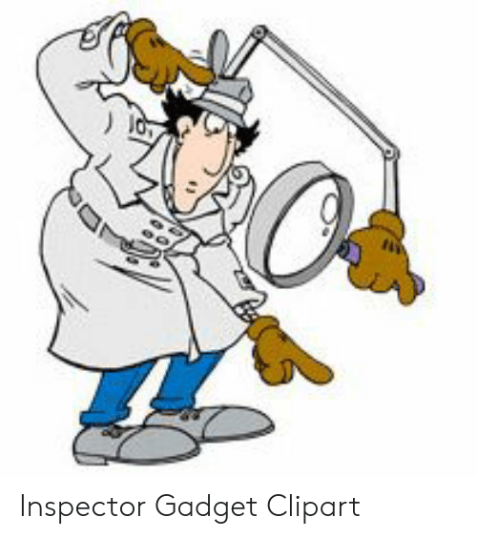
b) Find the…
window – 1
door – 2
chairs - 3
desk(table) – 4
blackboard – 5
books – 6

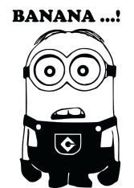

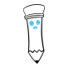
3. Draw! What’s your favourite…
… animal? … food? … colour? …season?
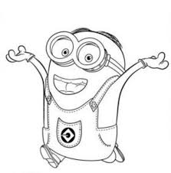
4. - Thank you!
_______________ (YOU’RE WELCOME! / OK! / THANK YOU! )
- Good bye!
_______________ (HEllO! / GOOD BYE! / THANK YOU! )

What do you think of this worksheet? Colour the stars!
EASY! HARD! I LIKE IT! I DON’T LIKE IT!

