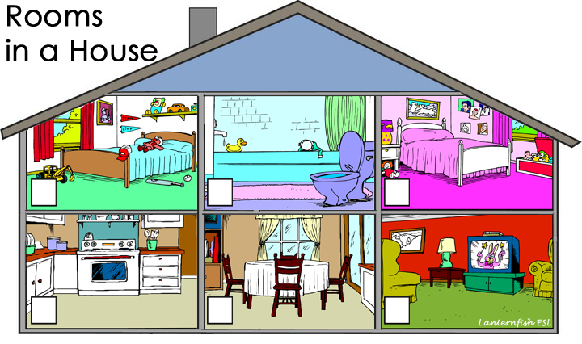
Number the rooms in the picture above.
1. bathroom | 2. bedroom | 3. dining room | 4. kitchen | 5. living room

Practice writing the names of rooms in a house.
©2010 Lanternfish ESL at www.bogglesworldesl.com

