Hello. How are you?

WORKSHEET 7 (in your notebook)

https://www.youtube.com/watch?v=PkUlCIFE45M
Watch the video and pay attention to the vocabulary (use your dictionary).

1) Match the pictures with the pieces of advice.

- Use a household wipe or spray to disinfect doorknobs, light switches, desks, keyboards, sinks, toilets, cell phones, and other objects and surfaces that are frequently touched.
- Wash hands with soap and water for at least 20 seconds. Dry them thoroughly.
- Use a tissue to cover a cough or sneeze, then dispose of it in the trash.
- Use a hand sanitizerwith at least 60% alcohol.
- Take vitamins.
A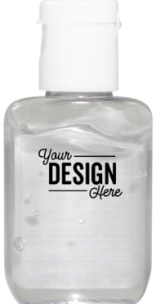 B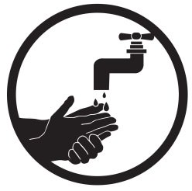 C
D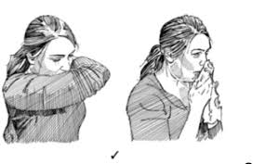 E F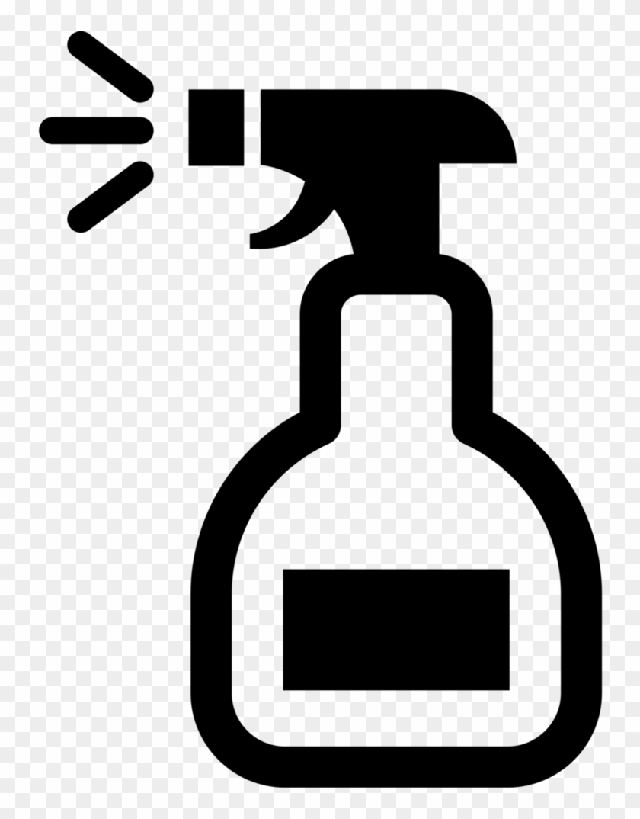
- Avoid touching your nose, eyes, and mouth.
- Do not leave your hands dirty.
- Stay home if you feel sick.
- Do not meet old people. They get ill more easily.
- Do not travel.
- Use a face mask.
- Try to stay happy and balanced.
- Do not meet other people.
- Use your bent elbow to cover a cough or sneeze.

G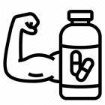H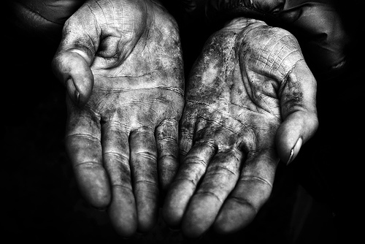IJK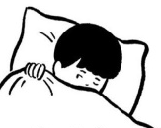LM N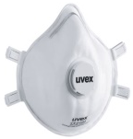

1. | 2. | 3. | 4. | 5. | 6. | 7. | 8. | 9. | 10. | 11. | 12. | 13. | 14.
2) Write the questions. Answer Yes, I do. or No, I don´t.
* at / play / Do / games / ? / computer / the / you / weekend
_______________________________________ _________
*TV / watch / on / ? / Mondays / Do / you
_______________________________________ _________
*the / Do / guitar / Tuesdays / play / on / ? / you
_______________________________________ ________
*table / play / Do / tennis / weekend / ? / at / you / the _____

3) Complete the text.
friends, hours, play, listen to, table tennis, don´t

On Saturdays, I sleep for about nine __________ . I _________ watch TV because I haven´t got a TV ! I _________ computer games for about two hours and I _________ CDs. I play football and ___________ with my ___________.

