WORKSHEET 12

1.- Watch and remember:
https://www.youtube.com/watch?v=AnZxeX_8mVk

2.- Write the subjects:
* rat = art (example)
*ghlinEs = English
*tamhs = maths
*phgeyrago = geography
*E.P. = P.E.
*ceniesc = science

3.- Write in negative:
* I have got art and design on Mondays.
I haven´t got art and design on Mondays.
*Tim has got English at half past twelve.
Tim hasn´t got English at half past twelve.
*I am a student. I´m not a student.
*We have got maths at nine o´clock on Fridays.
We haven´t got maths at nine o´clock on Fridays.

4.- Watch the video and sing:

https://www.youtube.com/watch?v=Ow_gbuqQC-k

5.- Watch the video and enjoy!
https://www.youtube.com/watch?v=iJdxTbFftXk

6.- Answer the questions:

This is Peter. He is eight years old. 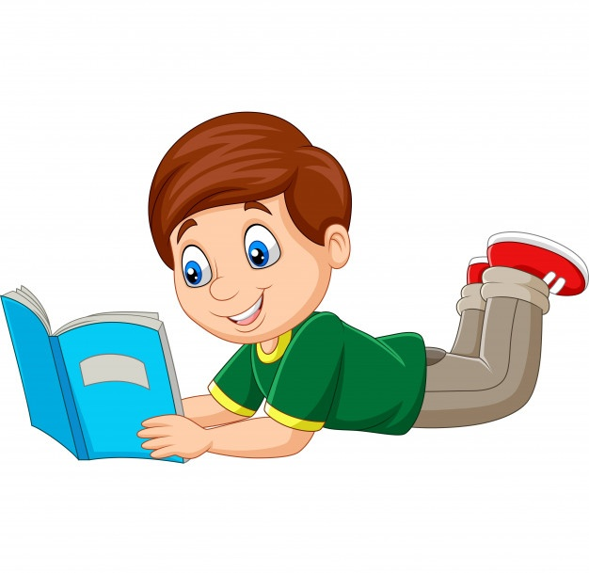
* What´s his name? His name is Peter.
* How old is he? He is eight years old.
* What colour are his eyes? His eyes are blue.
* What colour is his hair? His hair is brown.
* Has he got long hair? No, he hasn´t.
* What colour is his book? It´s blue.
* Has he got shoes ? Yes, he has.
* Has he got curly hair? No, he hasn´t.
* Has he got big eyes ? Yes, he has.
* Is he happy ? Yes, he is.
* Is he very tall? No, he isn´t.

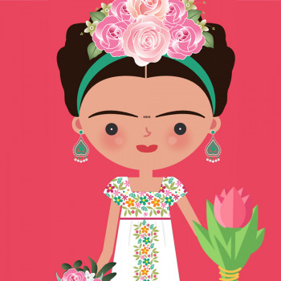
* Has she got earrings? Yes, she has.
*Has she got short hair? Yes, she has.
*What colour are her eyes? They are black .
*Are her eyes small? Yes, they are.
*Is she fat? No, she isn´t.
*Is her nose big? No, it isn´t.

