4 (in notebook)
WORKSHEET 1
1.- Write the days in the right order:
Thursday, Tuesday, Saturday, Wednesday, Monday, Sunday, Friday
1.- ___________________________ 5.- ___________________________
2.- ___________________________ 6.- ___________________________
3.- ___________________________ 7.- ___________________________
4.- ___________________________

2.- Complete the sentences :
There are There´s There are There´s There´s There are
_______________________ a hospital.
_______________________ three museums.
_______________________ a newsagent´s.
_______________________ two hospitals.
_______________________ shops.
_______________________ a police station.

3.- Answer these questions:
Are there two supermarkets in our town? Yes, ____________________________
Is there a rubber in your pencil case? Yes, _______________________________
Is there a train station in your town? No, ________________________________
Are there two hospitals near here? No, _________________________________
Is there a police station in the street? Yes, _______________________________

WORKSHEET 2
What time is it?
1.- Draw the time :
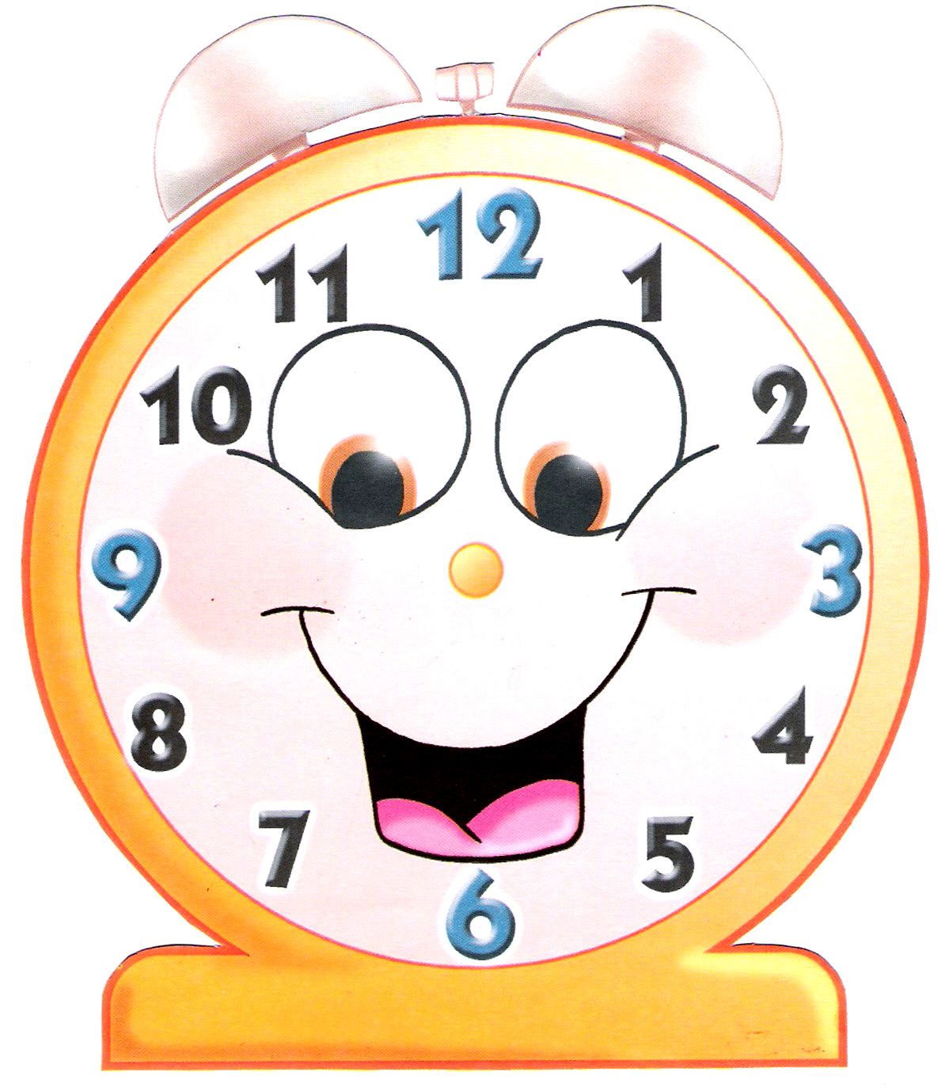 It´s twelve o´clock.

It´s quarter to three.
It´s half past eight.
It´s quarter past six.

