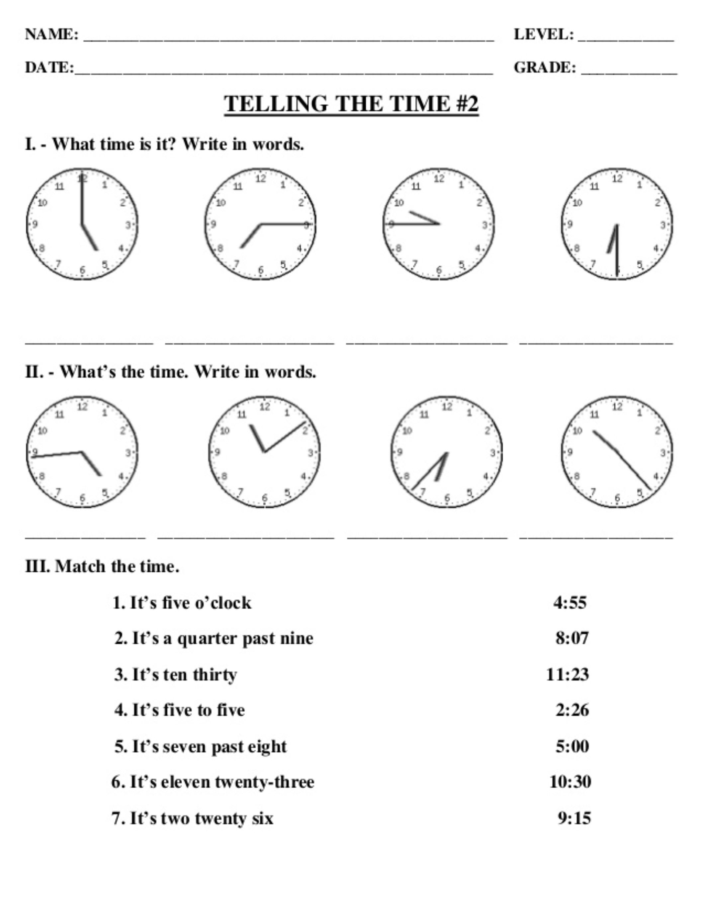
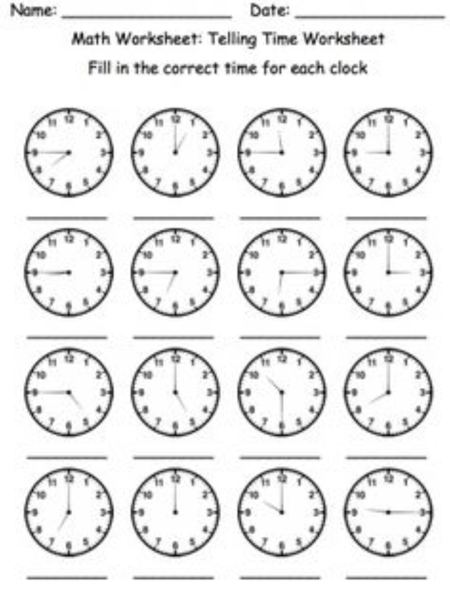
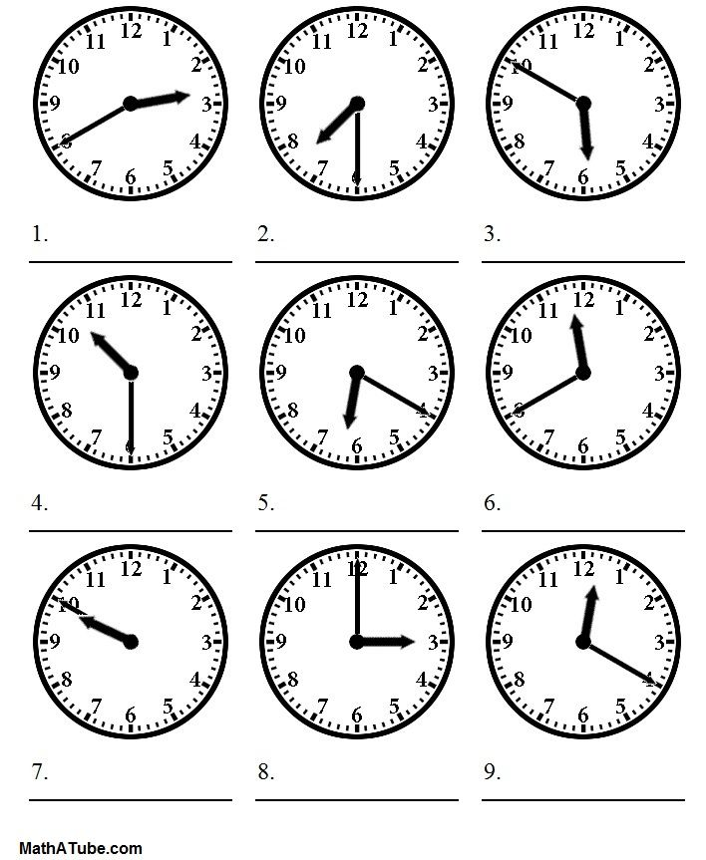
Personal Pronouns |  | Possessive Adjectives and Pronouns |  | Reflexive Pronouns
Subject form | Object form | Possessive adjective | Possessive pronoun | Reflexive Pronouns
I | me | my | mine | myself
you | you | your | yours | yourself
he | him | his | his | himself
she | her | her | hers | herself
it | it | its | its | itself
we | us | our | ours | ourselves
you | you | your | yours | yourselves
they | them | their | theirs | themselves

Personal Pronouns - Subject Form.

Example: We have got some books.

Personal Pronouns - Object Form.

Example: The books are for us.

Possessive Adjectives.

Example: These are our books.

Possessive Pronouns.

Example: The books are ours.

Reflexive Pronouns.

Example: He can carry the bags himself.

Pronouns:

Interactive Exercises and links:

Personal Pronouns - Subject Form
example: We have got some books.
Exercise on personal pronouns - subject form

Personal Pronouns - Object Form
example: The books are for us.
Exercise on personal pronouns - object form

Possessive Adjectives
example: These are our books.
Exercise on possessive adjectives

Possessive Pronouns
example: The books are ours.
Exercise on possessive pronouns

Entrar no seguinte link para practicar exercicios online dos contidos das unidades 3 e 4 así como tamén de contidos anteriores para repasalos. Recomendo empezar polo curso 1 para repasar tamén estruturas básicas que se utilizan a diario.

https://elt.oup.com/student/grammarfriends/?cc=global&selLanguage=en

