LOOK AT THE PAINTING
THE MONA LISA IS ALSO CALLED `LA GIOCONDA´
THIS PAINTING HAS GOT MANY SECRETS.
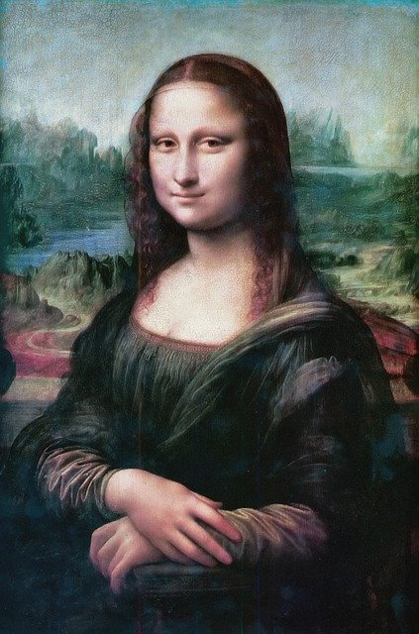
WRITE SOME SENTENCES ABOUT MONA LISA.
FOR EXAMPLE:
1, SHE HAS GOT STRAIGHT HAIR.
2. SHE HASN´T GOT A MOUSTACHE.
3.
4.
5
6
7.
8.

