Match the animals to the words.
1

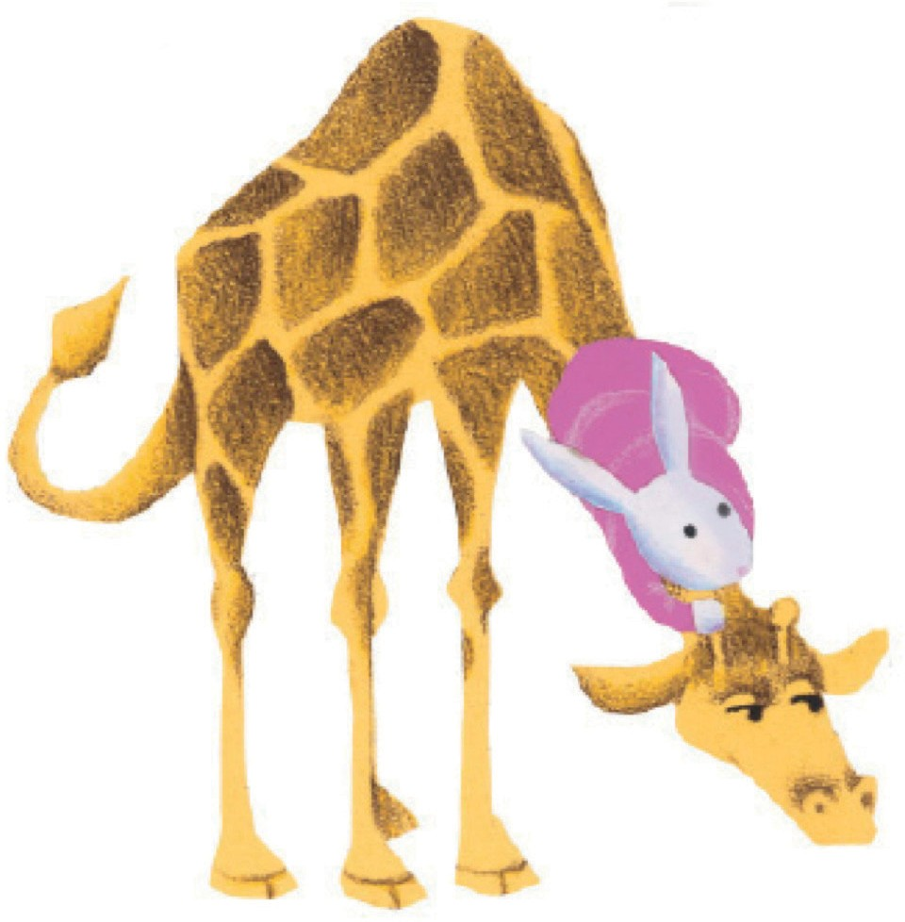
1.

- Tiger

- Crocodile

- Rabbit

- Lion

- Hippo

- Giraffe

- Elephant

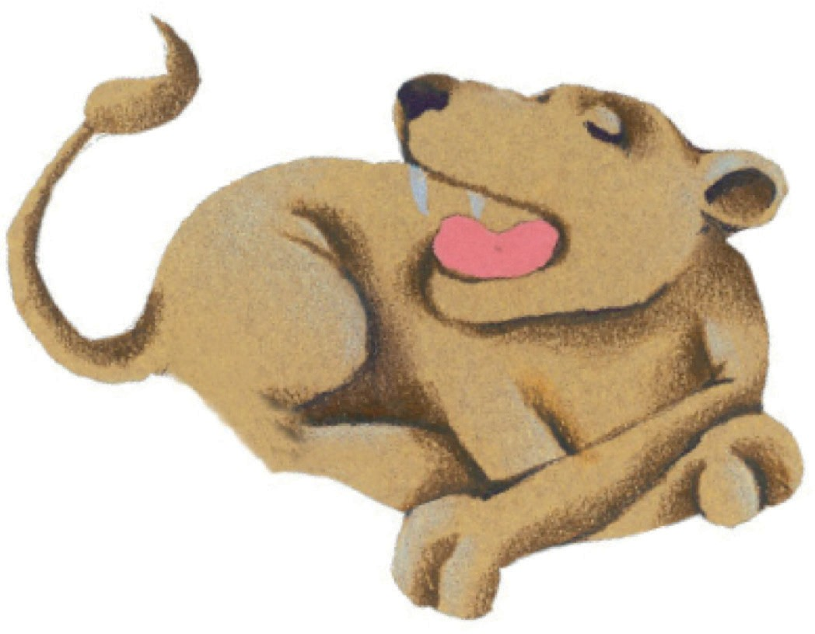
3.
6.
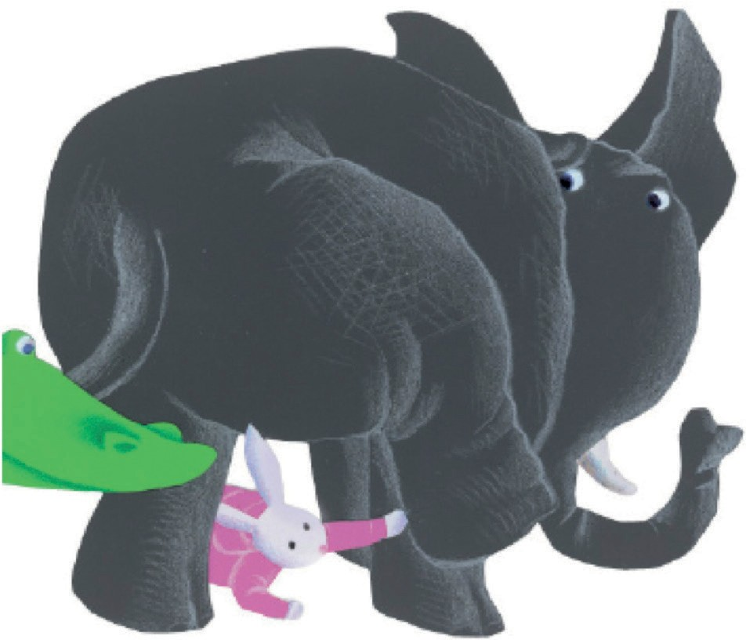
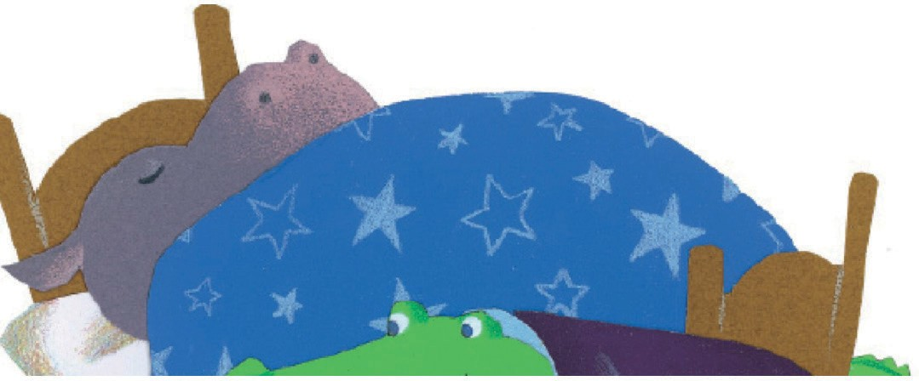
5.
7.

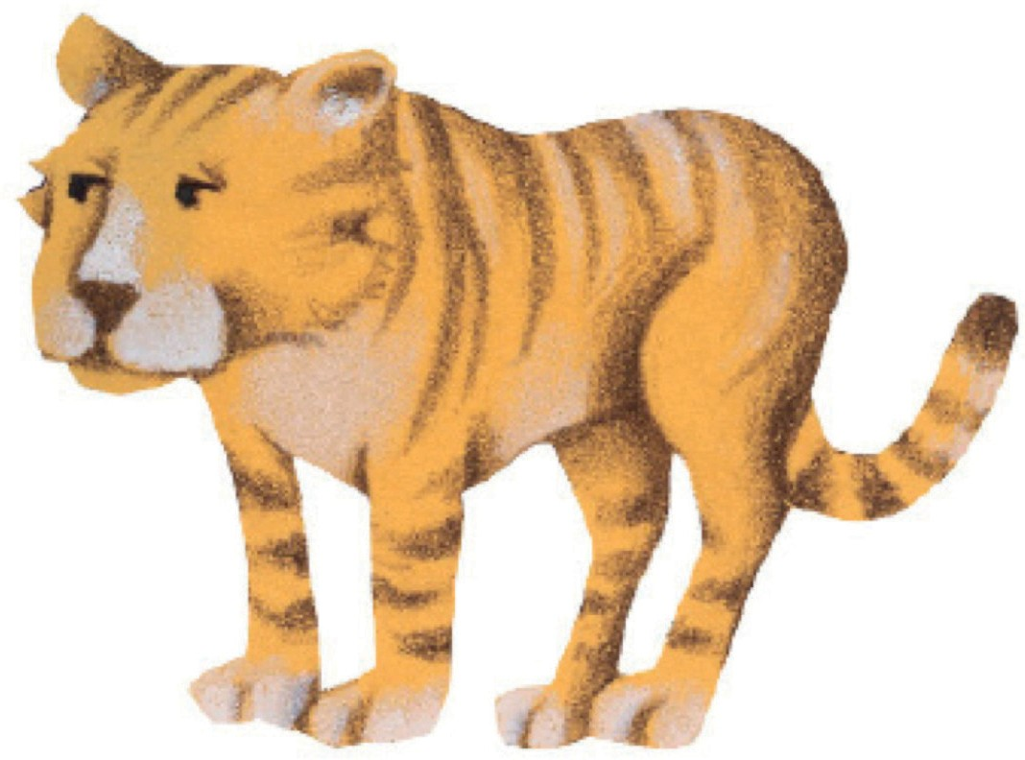
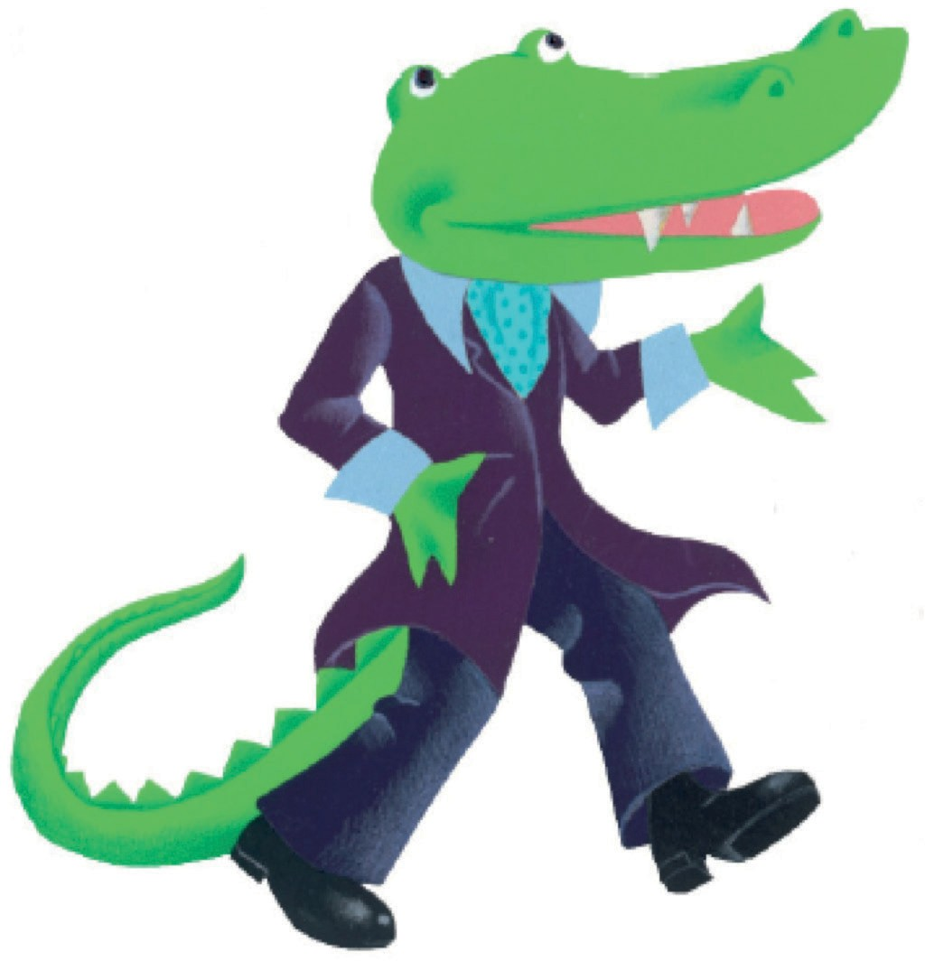
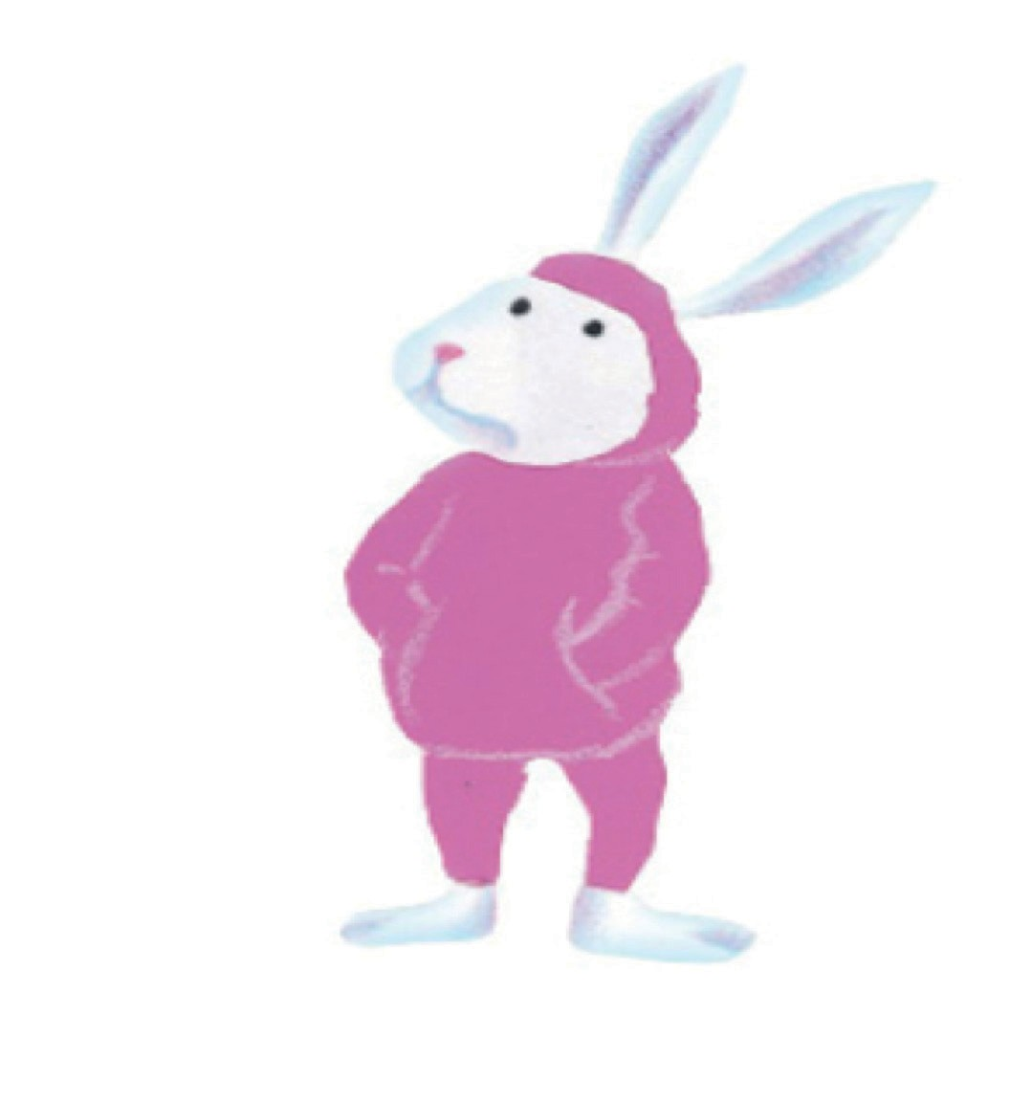
2.
4.
© Macmillan Publishers Limited 2020
Page 1

PHOTOCOPIABLE

What’s your favourite animal? Write and draw.
2

My favourite animal is a

What colour is your toothbrush? Write and colour.
3

My toothbrush is

