HI KIDS
- THIS IS YOUR OWN PAINTING. COLOR IT.
THE MONA LISA
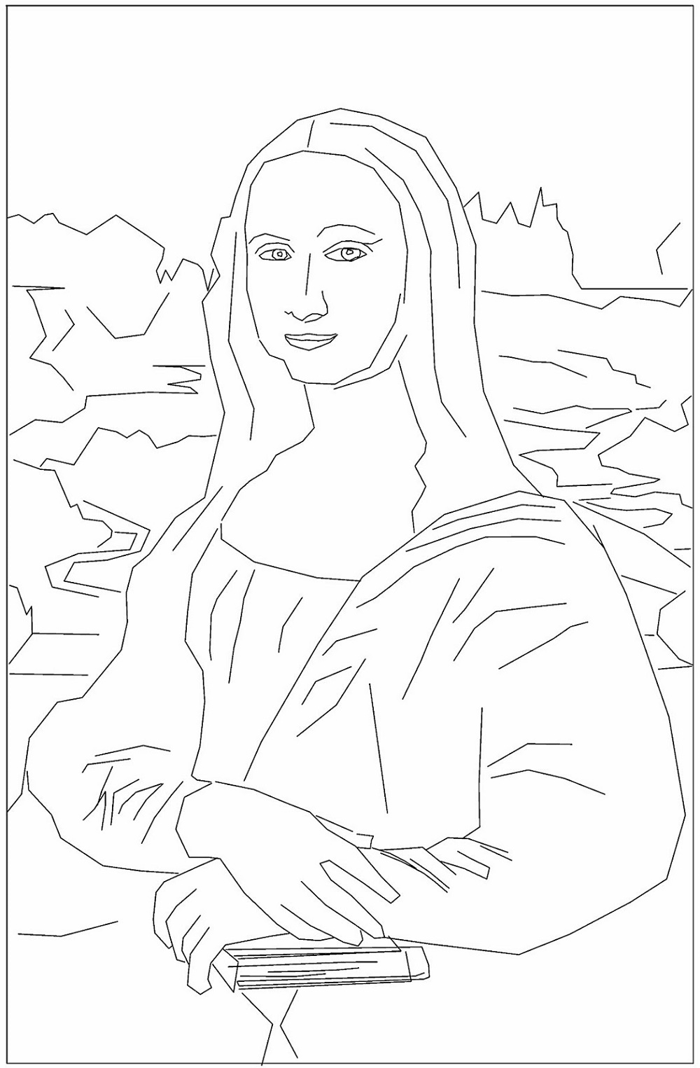
BY …………………………………….. ( WRITE YOUR NAME ).
DATE: WEDNESDAY 1 ST APRIL, 2020. 4TH GRADE

