HI KIDS
- THIS IS YOUR OWN PAINTING. COLOR IT.
THE MONA LISA
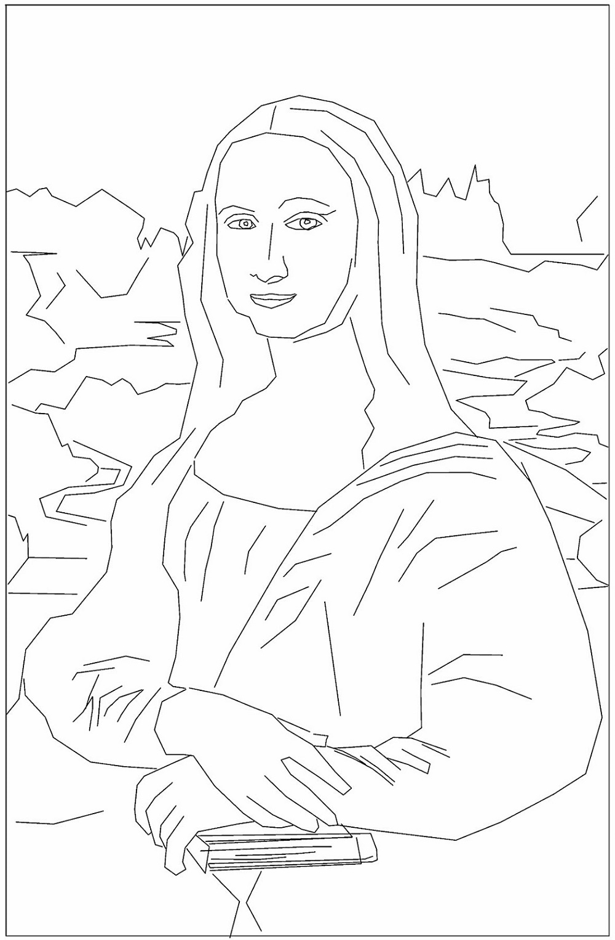
BY …………………………………….. ( ESCRIBE O TEU NOME).
DATE: TUESDAY 31 ST MARCH, 2020. 3RD GRADE

