LOOK AT THE PAINTING
THE MONA LISA IS ALSO CALLED LA GIOCONDA
THIS PAINTING HAS GOT MANY SECRETS.
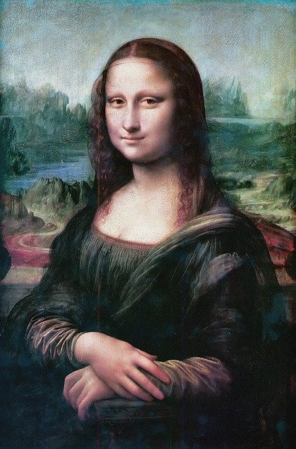
LOOK AT HER EYES… WHAT DO YOU SEE?

LOOK AT HER SMILE…. WHAT DO YOU SEE?
SADNESS, HAPPINESS,MELANCHOLY,…….

DO YOU WATCH MORE DETAILS? WRITE THEM.

