Are these amphibians? YES or NO
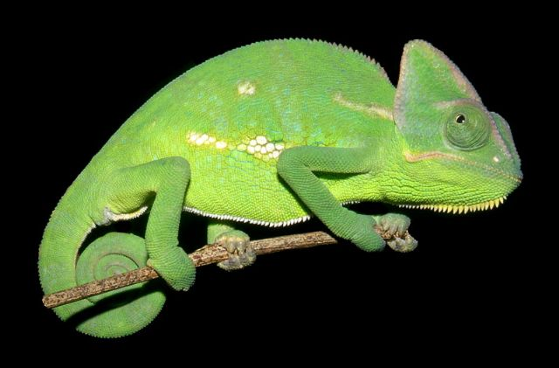
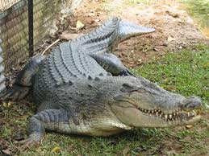
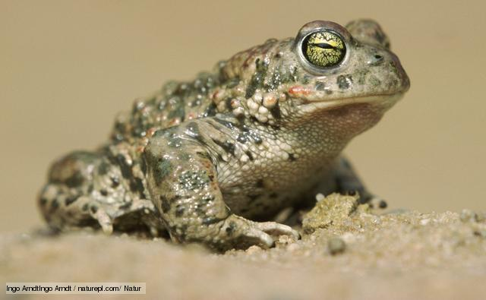
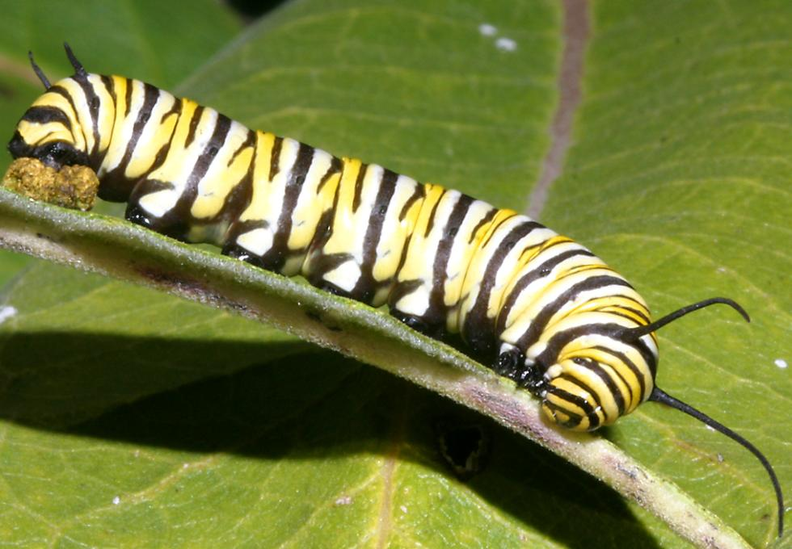

If your answer is : Yes , why do you think so?

Write true or false.

Amphibians have got hair.

Amphibians has got four legs

We always find amphibians on land.

